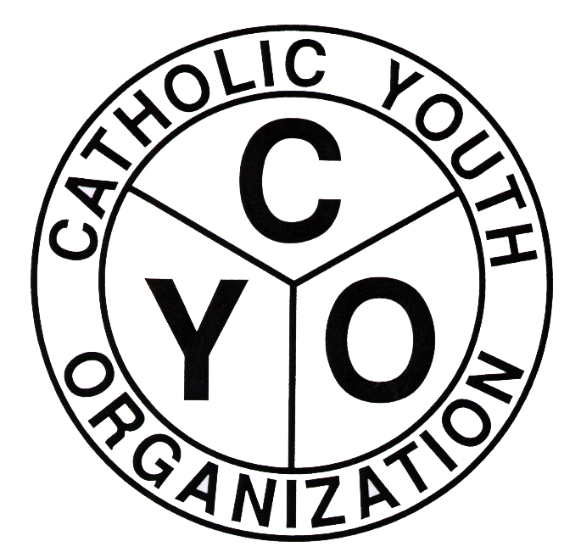
Catholic Youth Organization
Diocese of Brooklyn/Queens
7200 Douglaston Parkway, Douglaston, NY 11362
Tel.: 718.281.9548
Fax.: 718.281.9557
Web: www.cyodob.org

CYO RETURN TO PLAY SAFELY GUIDELINES, PROTOCOLS AND PROCEDURES

In order to ensure the highest standard of safety for all athletes, families, coaches, parish leaders and officials as well as meet our new public health obligation, we are implementing physical and procedural changes to the Catholic Youth Organization’s games and events. A full COVID-19 operations plan will include the following protocols and guidelines which will be continually updated in accordance with guidelines from the CDC, local, state and Diocesan officials.

- Adhere to best practices and recommendations from public health officials and those of all the schools, academies and NYC Parks Department fields, courts and facilities we are using where CYO practices, games and events are scheduled. All facility specific protocols and guidelines must be followed.
- Coaches, players, parish leaders, officials and permitted spectators must stay home if they do not feel well. Any player, parent, guardian, volunteer, coach or referee that has health conditions and/or immuno-deficiencies should use their best judgement and not attend games/practices.

- Coaches, players, and officials will be required to arrive wearing a face covering. Face coverings may only be removed during game play by active participants. Maintain social distancing in the designated spectator area and on the bench. Players and Coaches on the bench are required to wear face masks as well as those parents/guardians in the designated spectator area.

- Officials should have a face covering in their possession at all times in the event that they need to interact closely with players and/or coaches.

- An initial limiting of gatherings to no more than 50 people means that teams should not exceed 12 players indoors (preference for 10 players at games, but realize that teams have historically had more than 10; rosters can contain more than 10 players) and 15 players outdoors. Limitation guidelines are subject to change as the year progresses.

- Only one parent/guardian will be able to attend games. Home field/court coordinators must clearly designate separate entrances and exits, to the extent practicable.

- Home teams must have several game balls that are clean, sanitized and available for rotation into the game. Any ball removed from play must be properly sanitized before being inserted back into the game.

- Home gyms should have plenty of hand sanitizer so that the athletes and participants can maintain proper hygiene. For outdoor sports coaches must include sufficient amounts of hand sanitizer as part of their first aid kit.

- Athletes must bring their own water bottles to all games, practices and events. Indoor water fountains are not to be in use. Outdoor water fountains are not recommended to be used.

- Home teams should have a Facility Coordinator on premise to act as a Social Distancing Ambassador.

- Allow greater time in between scheduled games so there is less interaction among participants. A buffer time period of up to 30 minutes will be added between scheduled games.

- Teams and permitted spectators will be allowed entry into the facility no more than 15 minutes prior to game time or at the discretion of the facility coordinator. At the conclusion of each scheduled game all participants and permitted spectators must leave the facility and not congregate or hang around in order for the next game or event participants to enter safely.

- Player benches and high contact surfaces should undergo disinfection prior to having another team occupy the same environment for the next scheduled game.

- Parish leaders and site coordinators provide assurances that the gyms, bathrooms, kitchens (if used) and high contact surfaces will be properly cleaned at the end of day of games or practices.

- There will be an absolute time limit to games so that we remain on schedule and preclude the possibility of teams arriving to games before the prior game is over. For example, a 1pm basketball game will be declared over at 2:10pm so that the gym can be emptied in time for the 2:30pm game that follows.

- No handshakes or high fives will be permitted among opponents before, during or after the game. The CYO prayer and code of conduct must be read prior to each game with participants remaining at their bench following proper social distancing protocols.

- PARs, Athletic Directors and Coaches will be kept updated on all COVID-19 procedures, guidelines and protocols.

- A condensed season schedule may be created for all sports to provide the opportunity for a safe return to play for our athletes as our main goal.

- Waiver of liability language must be updated to include risk of exposure to COVID19. The attached release and waiver of liability form must be completed and submitted at the time of parish registration for each CYO parent and participant.

- If a player, coach or anyone directly associated with a team becomes exposed to COVID19, then the team will NOT play any games or hold practice for a period of time as mandated by the CDC and health officials.

- Modifications to sport specific rules of competition and time adjustments will be clearly noted in the sport fact sheet and athletic manual.

The children in the Catholic Youth Organization need the positive mental and physical health effects of playing sports together again. We have the responsibility to return our children to the fields, courts and sports facilities safely and smartly. There is an inherent risk in all activities amidst the COVID-19 Pandemic, but we can manage these risks by developing a systematic and clear way to safely operate our CYO league this year. As conditions and New York State guidelines change, we will revise and adapt our procedures and protocols to constantly provide the safest environment possible for our children, families, parish leaders, coaches and officials.
The CYO will continue to step up our efforts, continuing to offer a level of play that is competitive but also enjoyable for families to exercise temperance and balance participation with a quality of family life. Our sport system will continue to include these important values: child-centered, affordable, focus on bringing Christ into practice and competition, and teaching character through athletic participation.

